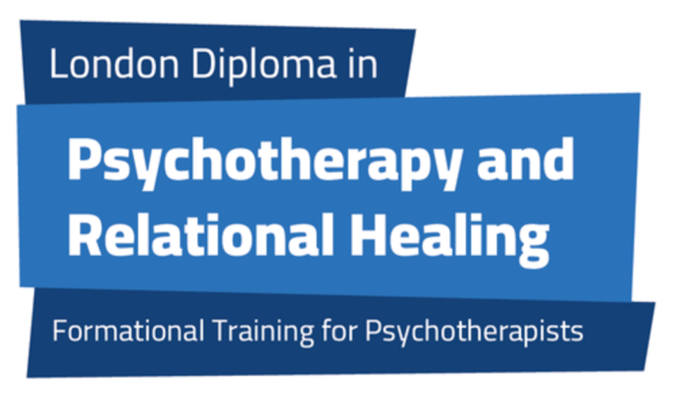

Application
Form

_________________________________________________________________________

Section 1- Personal/Contact Details

____________________________________________________________________________

First name (s): ...

Family name: ....

Gender (M/F/Other/Non-Binary):

Date of birth:.............................................

Country of birth: ...................................................

Nationality: ..........................................................

Address: .......

Principle telephone number: .................................................

Alternate telephone number: ........

Email address:

Can we use the above email address to contact you? YES /NO

Website, if appropriate: ...................................................................................................................

Your submitted application form is subject to the provisions of the Data Protection Act. For administrative purposes, basic details of those accepted on the LDPRH course are usually passed to COSRT in support of COSRT membership, The details passed on may include: your name, your address, your gender, your date of birth. Please advise us in writing if you wish to withhold permission for us to pass on such details for those purposes. At no time will your details be passed to anyone other than those involved in the training, course administration or professional governing bodies. Each student will placed on email distribution lists dedicated to their student cohort.
Full LDPRRH Data Privacy Policy: https://ldprh.org.uk/tac.html

Section 2 - Education

Schools/Colleges/Universities attended since the age of 15:

FromTo Name of Institution

Qualifications gained:

Date Qualification Subject Grade

Psychotherapy/Counselling training (if relevant):

Training institute/college: ..

Course title: .........

Start/end date of course: ....

Theoretical approach:

Qualification gained: .......................................................................................................................

Was your previous course accredited? ____________________________________________________________________________

Current occupation: .

Have you had any previous work experience as a counsellor or psychotherapist?

Details of any psychotherapy or counselling work experience if any:

Have you any experience as a counsellor of one-to-one or couples counselling?

Details of any one-to-one or couples counselling experience if any: .

Are you currently a member of any governing body or counselling organisation?

If YES, please give details (e.g. which organisation and status of membership):

To apply to the course, you need to have received a minimum of 30 hours personal therapy within the last two years please state:

Are you currently in therapy/counselling?

If not please state the dates you were in therapy/counselling: from…
Was this weekly? If not please state regularity: ...........

How many hours of therapy/counselling have you had thus far? ..........

Are you currently professionally insured?

Other relevant work experience (please insert an additional page if you need more space): ........

If you have any certified medical condition which may impact on your learning or attendance, please inform us here: ____________________________________________________________________________

Section 4 – Personal Statement

____________________________________________________________________________

____________________________________________________________________________

Section 5 - References

Please provide the name and email address of one professional referee, who we can contact:

In line with government guidelines, we need to ask whether you have a criminal record:

If YES, please provide details:

Section 6 - Declaration

I confirm that the information on this form is correct, to the best of my knowledge,

Signature: .................................................. Date:

Please keep a copy for your own records, and submit this application, together with a current CV, to the Course Director, Judi Keshet-Orr MSc. UKCP reg., either by scanning and emailing to: enquiries@ldprh.org.uk, or by posting to her at:

Judi Keshet-Orr
181 Hampstead Way
London NW11 7YA

